*DATA WAREHOUSE AND DATA MINING*

*ASSIGNMENT 5- Study and implement naïve bayes classification, decision tree algorithm, KNN with example.*

*NAME- GARGI YEKHANDE*

*ROLL NO- 25*

NAÏVE BAYES

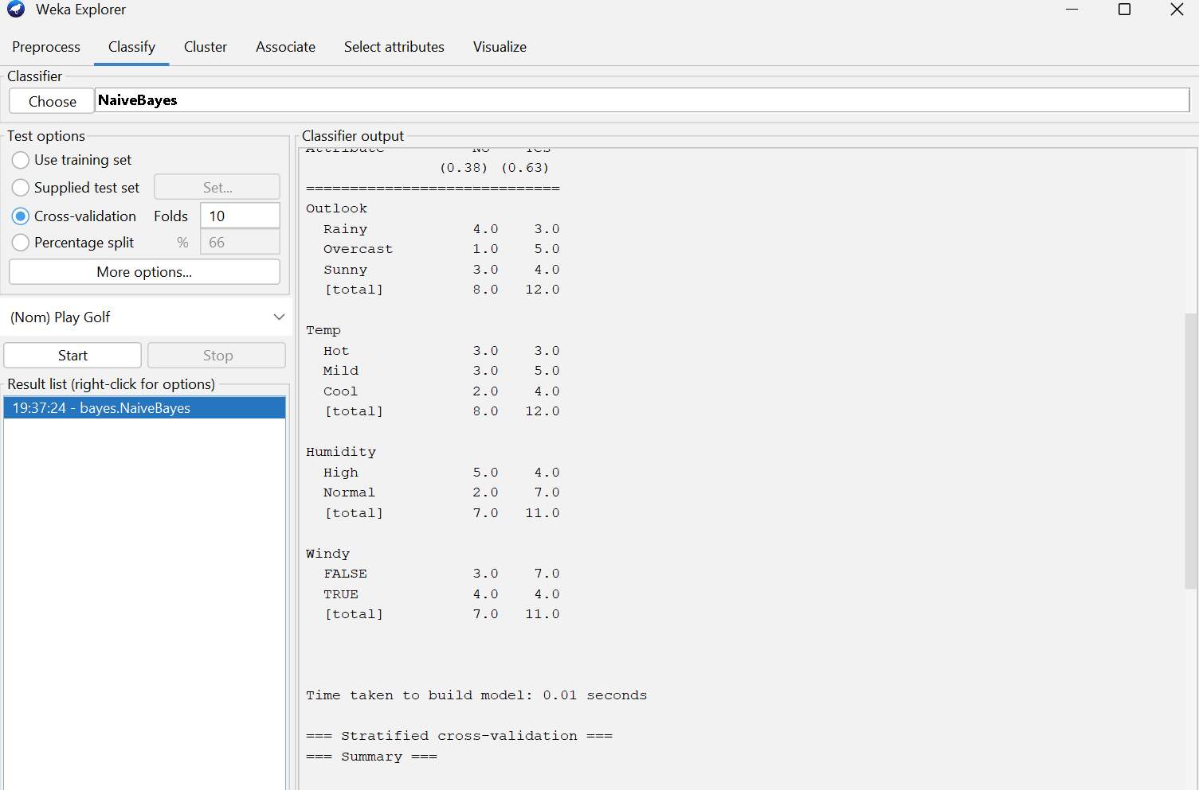

RA*N*DOM TREE:

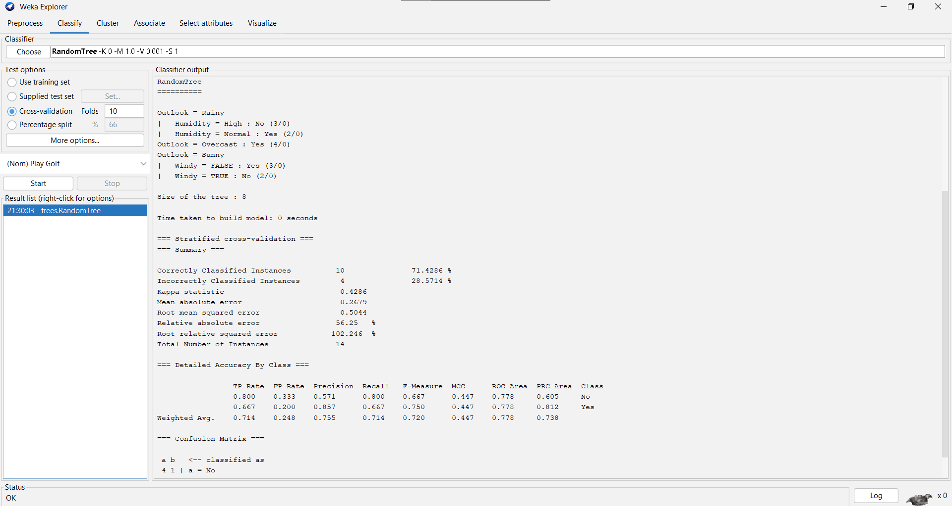

K*NN:*

